**2-3. Investigation on Fatigue Types**

For the dog bone fatigue, find the safety factor and the number of repetitive loads before fatigue failure (Life) for the following four cases. For cases 1, 2, and 3, compare the analytical results with the Goodman theory. In this case, a new SS400 material is created and used for the analysis (E=200GPa, v=0.3, tensile strength 400MPa, yield strength 250MPa, endurance limit at laboratory condition Se=200MPa at 106 cycles) Apply the fatigue strength factor = 0.50 considering values at the service condition.

* 주어진 조건대로 세팅하였다.
* It was set according to the conditions given.

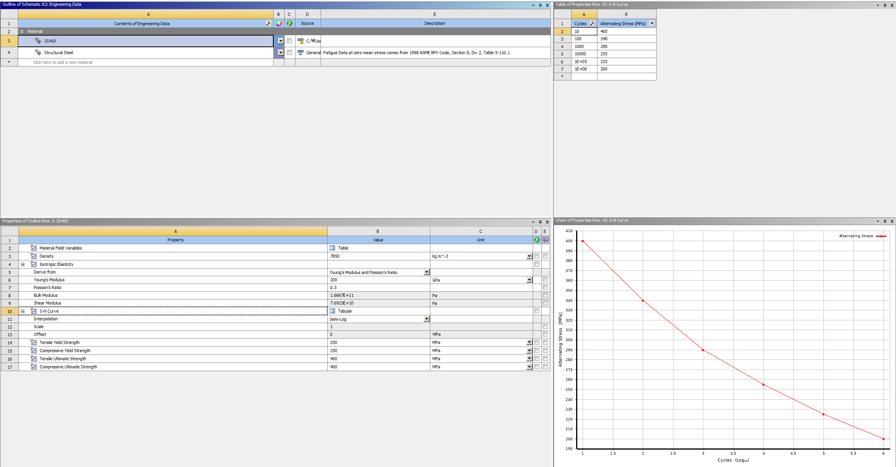

Figure 1. Material setting

* 응력을 구하기 위해 Figure 2를 활용하였다.
* Figure 2 was used to obtain the stress.

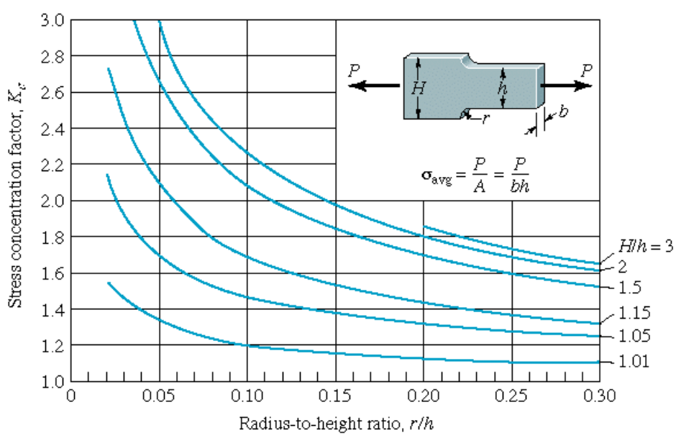

Figure 2. Stress Concentrations of Plate with Fillet

**1. Fully Reversed Apply cycles for infinite life**

(1) Fatigue safety factor for cycles

(2) Life: Cycles

(3) Compare results with Goodman's theory

|  |  |
| --- | --- |
| Safety factor | Life |
|  |  |

ANSYS를 활용하여 주어진 조건들을 토대로 설계하였다. 설계 후, 피로해석을 진행하였다. 위 모델의 경우, 안전율은 0.922이며, 유효 수명은 21113회이다. 즉, 21113회의 사이클이 돌았을 때, Min이라고 표기한 부분부터 파손이 발생하기 시작한다. Goodman’s theory를 이용하여 값을 비교해보자. 다음은 goodman’s theory 식이다.

Fully Reversed이므로, 이다. 주어진 조건을 활용하면, the fatigue strength factor = 0.5이므로 이고, 교번 응력 이다. 따라서, 🡪 N = 0.92217이 된다. 이론값과 ANSYS값을 비교해보면 유사하게 나온 것을 확인할 수 있다.

It was designed based on the conditions given using ANSYS. After the design, fatigue analysis was conducted. In the case of the above model, the safety rate is 0.922, and the effective life is 21113 times. That is, after 21113 cycles, damage starts to occur from the part marked Min. Use Goodman's story to compare the values. Next is the goodman's story equation.

Since type is Fully Reversed, the average stress is zero. Using the given condition, the fatigue strength factor = 0.5, so we can calculate this value. . In addition, since , alternating stress . Therefore, 🡪 N = 0.92217. Comparing the theoretical value with the ANSYS value, the result value was similar.

**2. Zero-based Apply cycles for infinite life**

(1) Fatigue safety factor for cycles

(2) Life: Cycles

(3) Compare results with Goodman's theory

|  |  |
| --- | --- |
| Safety factor | Life |
|  |  |

ANSYS를 활용하여 주어진 조건들을 토대로 설계하였다. 설계 후, 피로해석을 진행하였다. 위 모델의 경우, 안전율은 1.4754이고, 유효 수명은 1e6회이다. 하지만, life에서 모델이 빨간색으로 나왔으므로, 재료가 피로로 인해 손상되고 있다는 것을 알 수 있다. Goodman’s theory를 이용하여 값을 비교해보자. 다음은 goodman’s theory 식이다.

Zero-based이므로, 평균응력과 교번응력이 공존한다. 주어진 조건을 활용하면, the fatigue strength factor = 0.5이므로 이다. 또한, 이므로 교번 응력 , 평균 응력 이다. 따라서, 🡪 N = 0.147547이 된다. 이론값과 ANSYS값을 비교해보면 유사하게 나온 것을 확인할 수 있다.

It was designed based on the conditions given using ANSYS. After the design, fatigue analysis was conducted. In the case of the above model, the safety rate is 1.4754, and the effective life is times. However, since the model came out in red in life, we can see that the material is being damaged by fatigue. Use Goodman's theory to compare the values. Next is the goodman's story equation.

Since type is zero-based, average stress and alternating stress coexist. Using the given condition, the fatigue strength factor = 0.5, so we can calculate this value. . In addition, since , alternating stress , and average stress . Therefore, 🡪 N = 0.147547. Comparing the theoretical value with the ANSYS value, the result value was similar.

**3. R=-0.5 Apply cycles for infinite life**

(1) Fatigue safety factor for cycles

(2) Life: Cycles

(3) Comparison with Goodman's theory

|  |  |
| --- | --- |
| Safety factor | Life |
|  |  |

ANSYS를 활용하여 주어진 조건들을 토대로 설계하였다. 설계 후, 피로해석을 진행하였다. 위 모델의 경우, 안전율은 1.1349이며, 수명을 10^6까지 설정하였지만, 유효 수명은 1e6회이다. 하지만, life에서 모델이 빨간색으로 나왔으므로, 재료가 피로로 인해 손상되고 있다는 것을 알 수 있다. Goodman’s theory를 이용하여 값을 비교해보자. 다음은 goodman’s theory 식이다.

Ratio = -0.5이므로, 평균응력과 교번응력이 공존한다. 주어진 조건을 활용하면, the fatigue strength factor = 0.5이므로 이다. 또한, 이므로, 교번 응력 , 평균 응력 이다. 따라서, 🡪 N = 1.13498이 된다. 이론값과 ANSYS값을 비교해보면 유사하게 나온 것을 확인할 수 있다.

It was designed based on the conditions given using ANSYS. After the design, fatigue analysis was conducted. For the above model, the safety rate is 1.1349, and the effective life is times. However, since the model came out in red in life, we can see that the material is being damaged by fatigue. Use Goodman's story to compare the values. Next is the goodman's story equation.

Since type is ratio = - 0.5, average stress and alternating stress coexist. Using the given condition, the fatigue strength factor = 0.5, so we can calculate this value. . In addition, since , alternating stress , and average stress . Therefore, 🡪 N = 1.13498. Comparing the theoretical value with the ANSYS value, the result value was similar.

**4. History data: Apply SAE Bracket History Apply blocks for infinite life**

(1) Fatigue safety factor for 100 blocks load history

(2) Life: Block

|  |  |
| --- | --- |
| Safety factor | Life |
|  |  |

주어진 조건을 활용하여 History data를 통해 Safety factor, Life를 구해보았다. Safety factor은 다른 Type에 비해 상당히 작은 값인 0.0017761이 나왔다. 수명의 경우, Max부분을 포함한 안쪽 모서리 부분에서 높게 나온 것을 알 수 있었고, 전반적으로 모델의 수명이 0 block으로 짧은 것을 볼 수 있다.

Safety factor, Life were obtained through History data using the given conditions. The safety factor was found to be 0.0017761, a significantly smaller value than other types. In terms of life, it can be seen that it came out high from the inner corner including the Max part, and overall, it can be seen that the life of the model is short as 0 block.